**WEB TECHNOLOGY AND MOBILE APPLICATIONS**

**EXPERIMENT-1**

**AIM:**

HTML &amp; CSS

a) Create a web page to embed a map along with hot spot, frames &amp; links.

b) Create a web page using an embedded, external and inline CSS file.

**CODE:**

<!DOCTYPE html>

<html lang="en">

<head>

    <meta charset="UTF-8">

    <meta name="viewport" content="width=device-width, initial-scale=1.0">

    <title>Map with hotspot and frames</title>

    <link rel="stylesheet" href="style.css">

</head>

<h1>Explore the world with our map</h1>

<div id="map container">

    <iframe src="https://www.google.com/maps/embed?pb=!1m18!1m12!1m3!1d3023.8666140989024!2d-74.00601568459399!3d40.71277537933002!2m3!1f0!2f0!3f0!3m2!1i1024!2i768!4f13.1!3m3!1m2!1s0x89c25a1788a65369%3A0xe51e0853a051fc8d!2sNew%20York%2C%20NY!5e0!3m2!1sen!2sus!4v1646991302839!5m2!1sen!2sus"></iframe>

</div>

<div class=" hotspot ">

    <h2>discover new york</h2>

    <p>click the hotspot on the map to view new york</p>

    <a href="https://www.google.com/maps/place/New+York%22 ">view new york on google map</a>

</div>

<div class="webside">

    <h2>visit wikipidia</h2>

    <p>explore wikipidia right here</p>

    <iframe src="https://www.wikipedia.org/"></iframe>

</div>

<footer>

    <p>&copy; 2025 Map Exploration | <a href="https://www.example.com">Visit our website</a></p>

</footer>

<body>

</body>

</html>

Css

body {

    font-family: 'Poppins', sans-serif;

    background-color: #f4f7fc;

    margin: 0;

    padding: 0;

    color: #333;

}

header {

    background-color: #0077b6;

    color: white;

    padding: 20px 0;

    text-align: center;

}

#map-container {

    max-width: 800px;

    margin: 20px auto;

    border-radius: 8px;

    box-shadow: 0 4px 8px rgba(0, 0, 0, 0.1);

    overflow: hidden;

}

iframe {

    width: 100%;

    height: 400px;

    border: none;

}

.hotspot-info {

    background-color: #fff;

    padding: 20px;

    border-radius: 8px;

    box-shadow: 0 4px 8px rgba(0, 0, 0, 0.1);

    margin: 20px auto;

    max-width: 800px;

}

.hotspot-info a {

    color: #0077b6;

    text-decoration: none;

    font-weight: bold;

}

footer {

    background-color: #0077b6;

    color: white;

    padding: 15px 0;

    text-align: center;

    margin-top: 40px;

}

footer a {

    color: #fff;

    text-decoration: none;

    font-weight: bold;

}

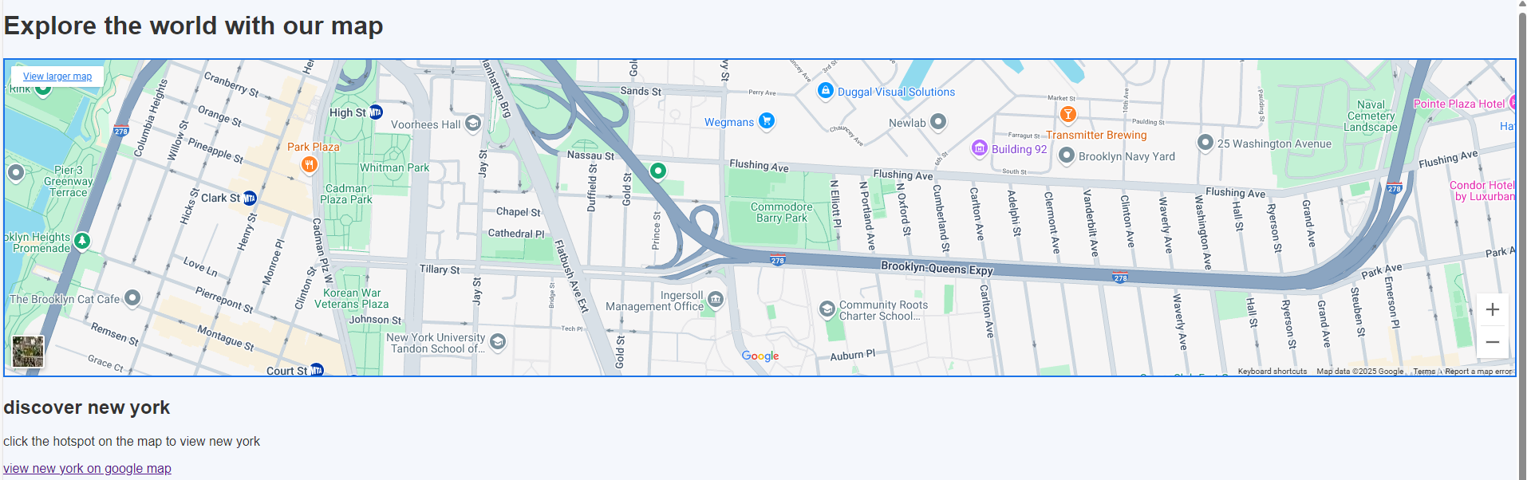

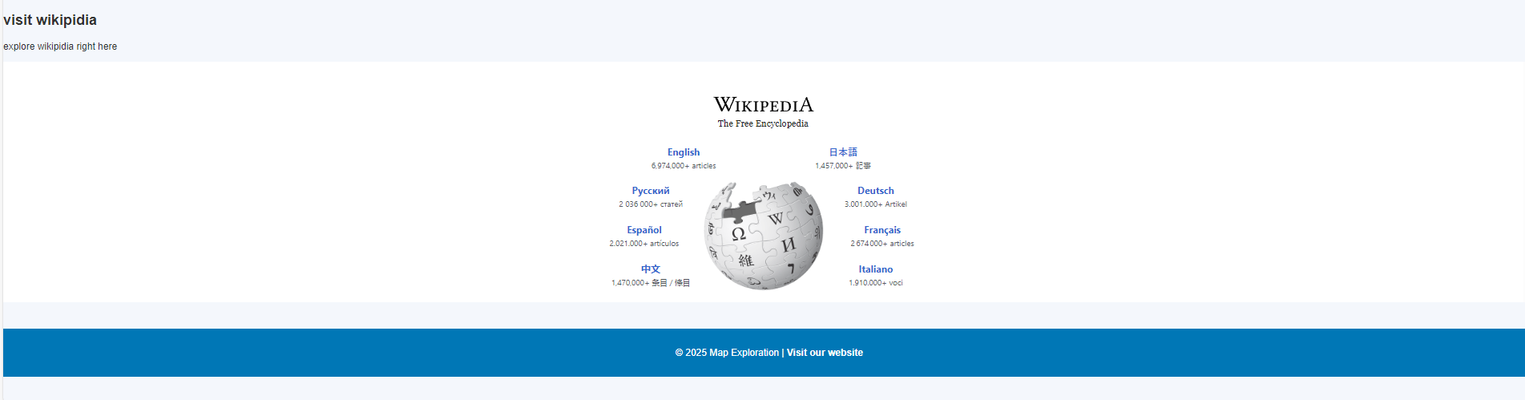

**Result**: Thus, a basic webpage with embedded maps, and a webpage illustrating different css was completed successfully.